**User guide**

**Step 1.** Click "View Date Readings" to navigate towards the Date Readings section. In this section the user has a range of selection on how to fetch records of past and current readings from a specific device.

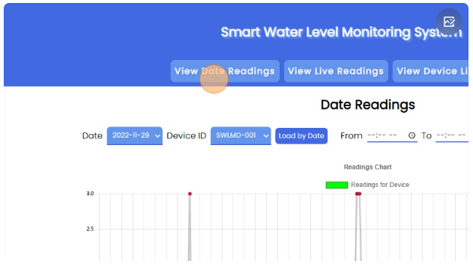

**Step 2.** Click this "Date" dropdown. The user can select when a reading occurred or initiated.

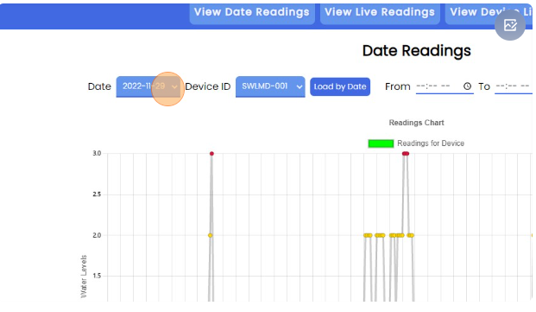

**Step 3.** Click this "Device ID" dropdown. To specify which device's record the user is looking for.

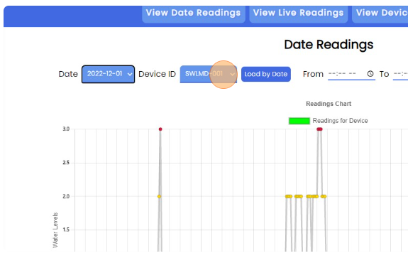

**Step 4.** Click "Load by Date". By clicking this button the user can then view the records associated by the chosen Date and Device.

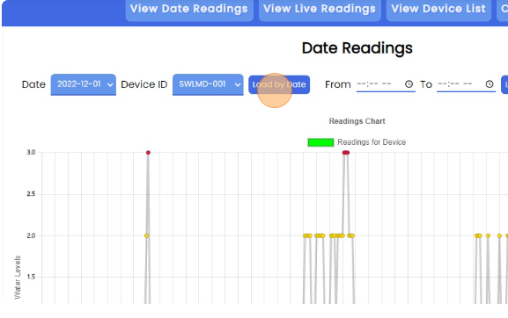

**Step 5.** Click this time field. By Selecting and filling the input "From" and "To" is by specifying which record to view starting from and to.

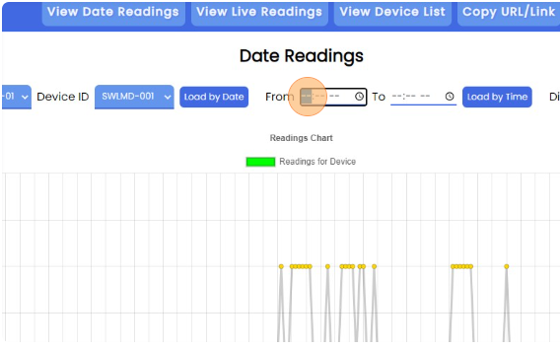

**Step 6**. Click here. In here we can see what time was this particular reading happened and shows which time and what the water levels were at that time.

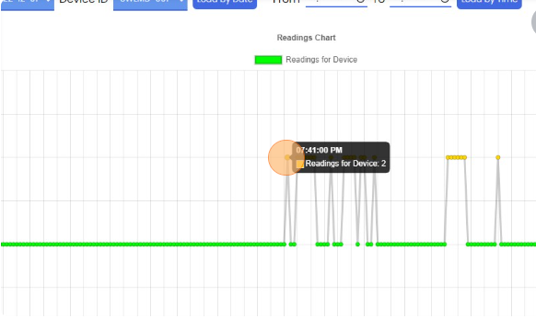

**Step 7**. Click "Load by Time". After filling the "From" and "To" fields. In which it specifies where to start fetching records from and where to stop.

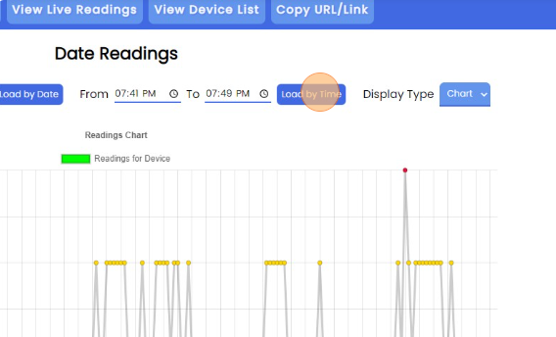

**Step 8**. Click this dropdown. By selecting which type of view you prefer.

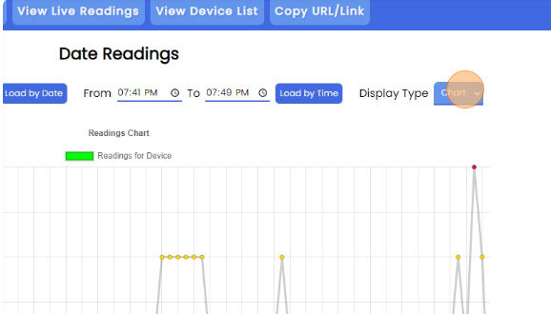

**Step 9**. Click "Load by Time" again. To load the same data. With a different type of display.

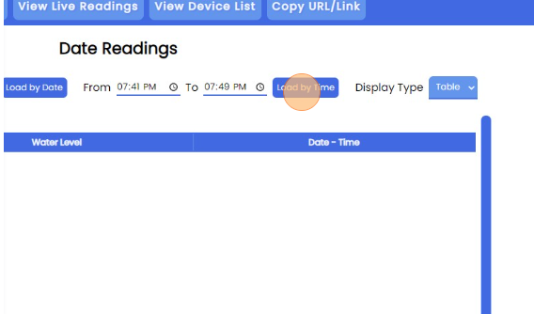

**Step 10**. Click "View Live Readings". It will navigate to another section. In this section we are viewing live data readings. From a specific device.

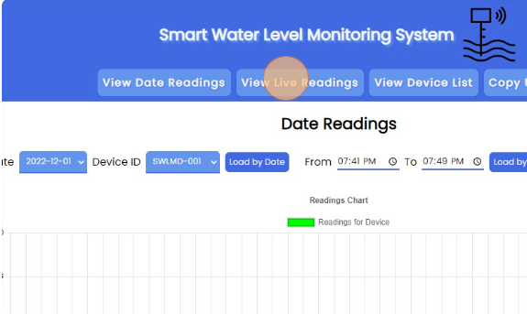

**Step 11**. Click this dropdown. In this dropdown, it specifies which device's readings the system will fetch records from.

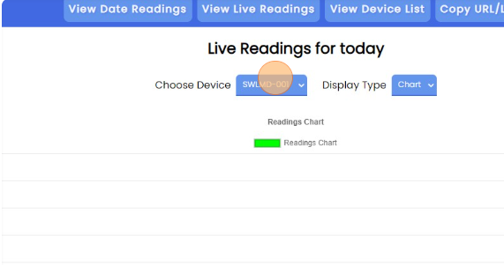

**Step 12**. Click "View Device List". This will navigate towards another section that loads all the device available.

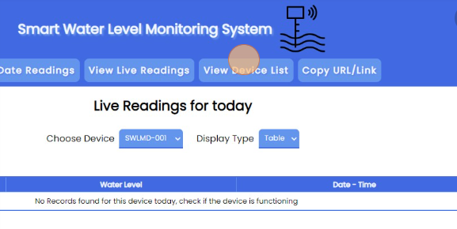

**Step 13**. Click the input field. To search for a specific device, location, or the when the device was added.

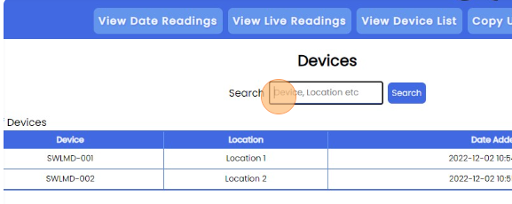

**Step 14**. Click "Search". The system then fetches all related or associated within the input fields. The results are then shown in the table below.

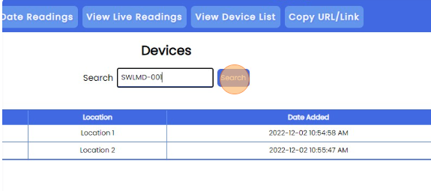

**Step 15**. Click "Copy URL/Link". By clicking this button it copies the websites current URL/Link so you can then share it with others.

